CS-255: DriverPass System Design Document Template
By: Justin Carlo Florida

The purpose of this system design document is to provide a detailed overview of the DriverPass system and how it meets the needs of the client. DriverPass is designed to help customers prepare for their driving tests by allowing them to select learning packages, schedule lessons, take practice tests, and manage their progress through an online platform.

This document includes several UML diagrams, such as use case, activity, sequence, and class diagrams, to illustrate how the system functions and how its components interact with one another. These diagrams help visualize user interactions, system processes, and the overall structure of the application.

In addition, this document outlines the technical requirements needed to support the system, including the hardware, software, tools, and infrastructure required for successful implementation. Overall, this design aims to create an efficient, user-friendly, and secure system that supports both customers and administrative staff in managing driving education services.

UML Diagrams

UML Use Case Diagram

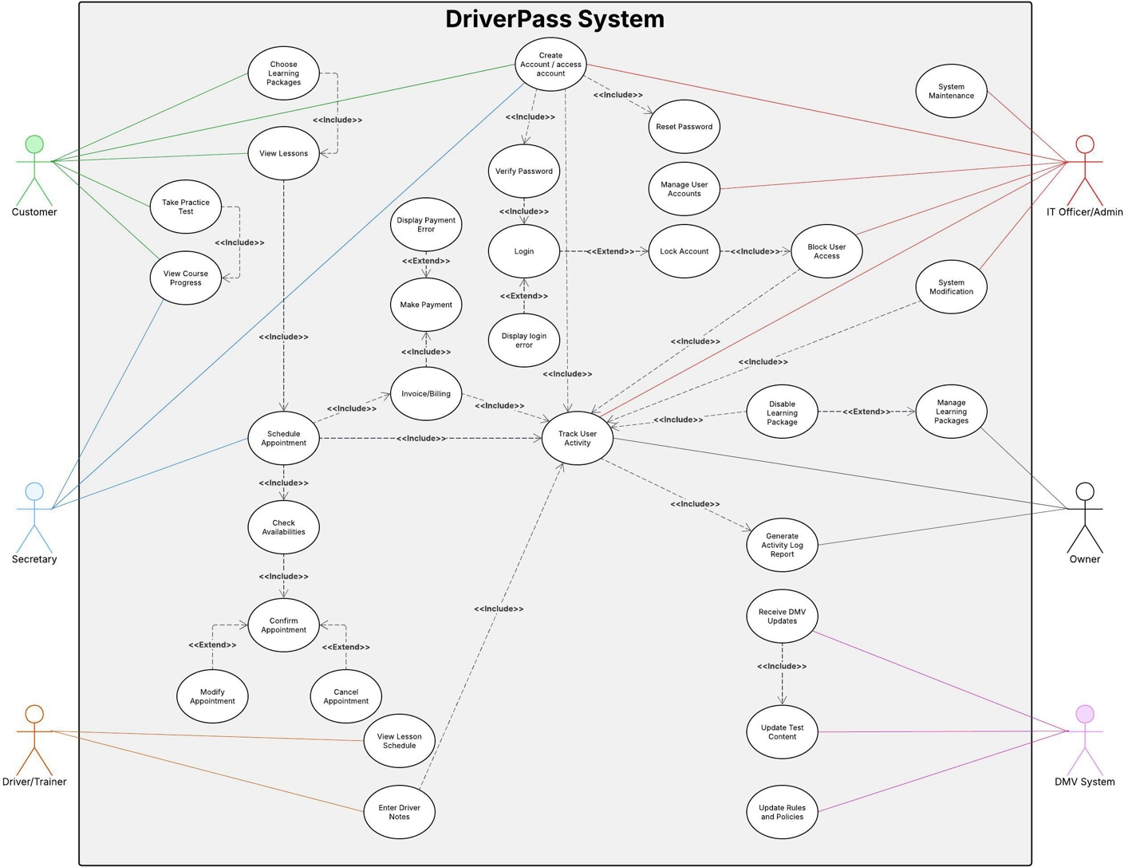

UML Activity Diagrams

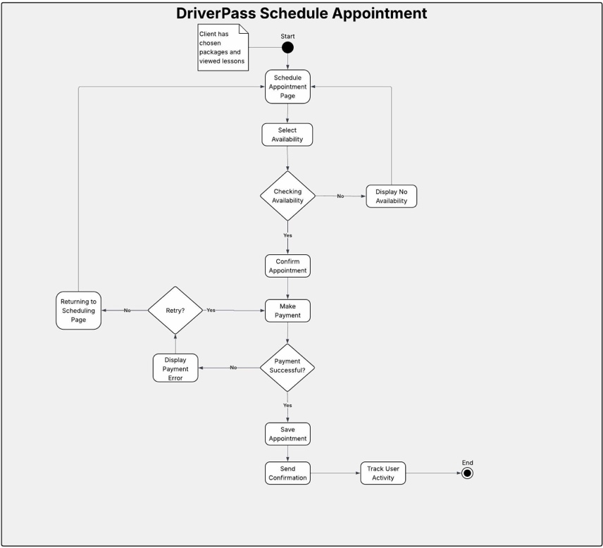

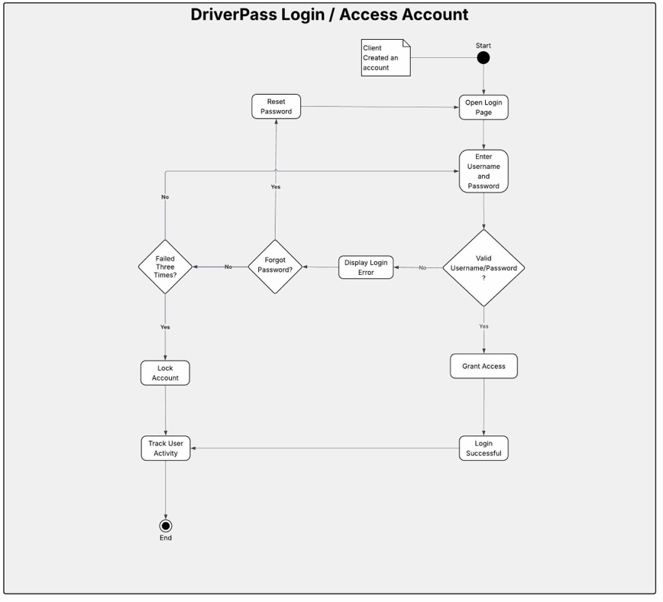

UML Sequence Diagram

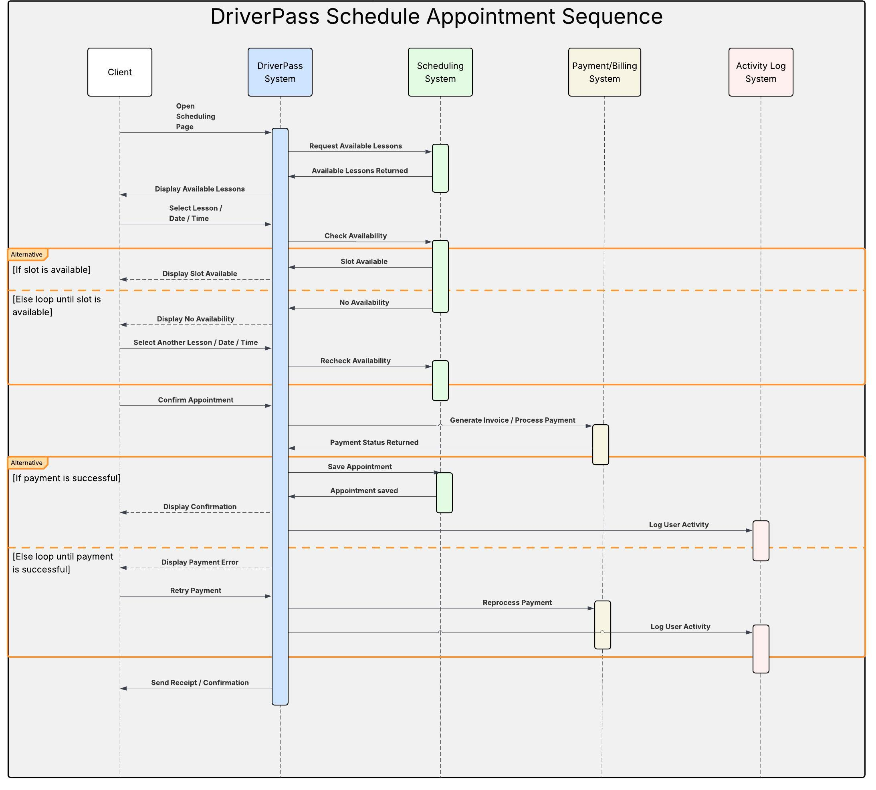

UML Class Diagram

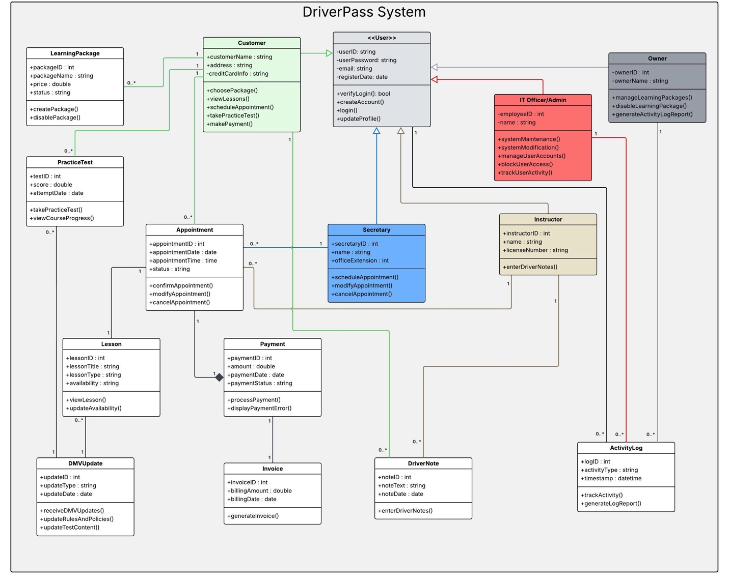

Technical Requirements

The DriverPass system requires a combination of hardware, software, tools, and infrastructure to support its functionality and ensure a smooth user experience for both customers and staff.

Hardware Requirements:
The system can be accessed using standard personal computers, laptops, tablets, or smartphones with internet connectivity. For administrative and staff users, a desktop or laptop computer is recommended to efficiently manage appointments, users, and system data. A stable internet connection is required for all users to access the system and perform tasks such as scheduling lessons and processing payments.

Software Requirements:
The DriverPass system will operate as a web-based application, meaning users can access it through modern web browsers such as Google Chrome, Microsoft Edge, or Safari. The system will require a backend server environment to manage user accounts, appointments, lessons, and payment processing. A database management system, such as MySQL or PostgreSQL, will be used to store and manage system data securely.

Tools and Technologies:
The system may be developed using common programming frameworks such as Java, Python, or JavaScript-based technologies. Development tools such as integrated development environments (IDEs), version control systems like Git, and testing tools will be used to build and maintain the system. UML modeling tools, such as Lucidchart, are used to design and visualize the system components and workflows.

Infrastructure Requirements:
The system will be hosted on a server or cloud-based platform to allow remote access by users. Cloud services such as AWS or similar platforms can be used to provide scalability, reliability, and data storage. The system will also require secure communication protocols, such as HTTPS, to protect user data during login and payment transactions. Backup and recovery systems should be in place to prevent data loss and ensure system availability.

